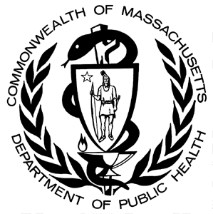

**Data Brief: Opioid-related Overdose Deaths Among Massachusetts Residents**

Massachusetts Department of Public Health Posted: august 2016

This report contains both confirmed and estimated data through June 2016. The number of confirmed cases of unintentional opioid overdose deaths for 2015 (n=1531) represents an 18% increase over 2014 (n=1294), and the 2014 number (n=1294) represents a 41% increase over cases for 2013 (n=918). In order to obtain timelier estimates of the total number of opioid overdose deaths in Massachusetts - confirmed and probable - DPH used predictive modeling techniques for all cases not yet finalized by the Office of the Chief Medical Examiner (OCME). Based on the data available as of 06/30/2016, DPH estimates that there will be an additional 47 to 67 deaths in 2014 and 107 to 150 deaths in 2015, once these cases are finalized. For the first 6 months of 2016, the number of confirmed cases of unintentional opioid overdose deaths was 488, with an estimated additional 431 to 509 deaths. Current estimates for the first 6 months of 2016 are higher than the first 6 months of 2015.

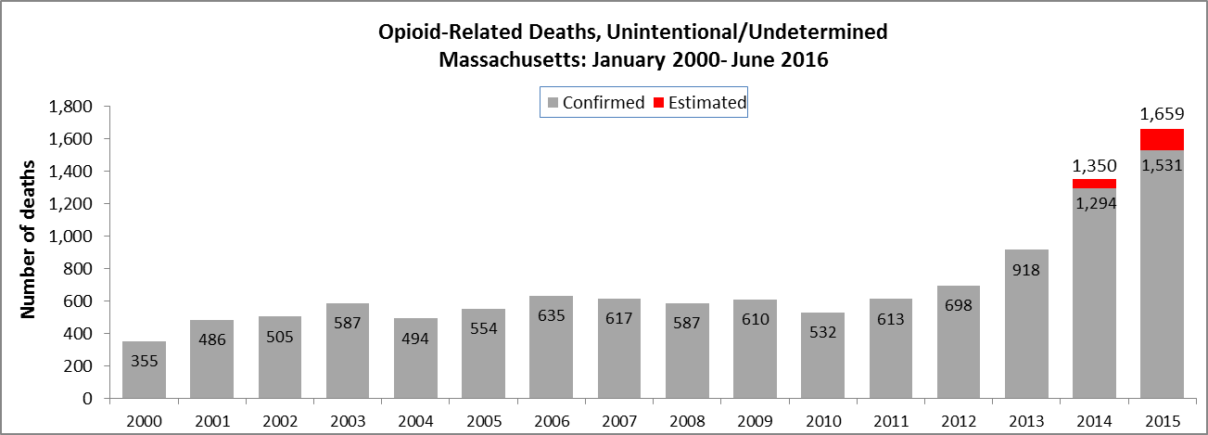

Note: Counts for 2000 – 2013 have been updated following a review of cases that did not receive an official cause of death at the time the files were closed.

DPH has also made month-by-month estimates for all intents (unintentional/undetermined and intentional deaths) from January 2015 through June 2016. By combining data from the OCME and the Massachusetts State Police, DPH is now able to estimate opioid-related deaths much closer to real-time than was previously possible.



**Rate of Unintentional Opioid Deaths**

In 2015, the estimated rate of unintentional opioid-related overdose deaths was 24.6 deaths per 100,000 residents. The 2015 rate is the highest ever for unintentional opioid overdoses and represents a 23% increase from the rate of 20 deaths per 100,000 residents in 2014.



1Unintentional poisoning/overdose deaths combine unintentional and undetermined intents to account for a change in death coding that occurred in 2005. Suicides are excluded from this analysis.

2 Opioids include heroin, opioid-based prescription painkillers, and other unspecified opioids. This report tracks opioid-related overdoses due to difficulties in identifying heroin and prescription opioids separately.

**Technical Notes**

The figures cited here for 2014-2016 are based on confirmed and estimated data. The Department regularly reviews projections as more information becomes available. Information from the Office of the Chief Medical Examiner and the Massachusetts State Police are now incorporated into the predictive model. This additional information has improved the accuracy of the models that predict the likelihood that the cause of death for any person was an opioid-related overdose. DPH applied this model to death records for which no official cause of death was listed by the OCME. The model includes information from the death certificate, Medical Examiner’s notes, and the determination by the State Police of a suspected heroin death. DPH added this estimate to the number of confirmed cases in order to compute the total number of opioid-related overdoses. Due to missing information on intent in the open files, the models predict the total number of fatal opioid-related overdoses. In order to estimate the numbers that are considered unintentional, the Department applied the average percentage of total opioid-overdose deaths that were considered unintentional for the previous 3-year period (97%) to the total estimate. Should new information become available that changes the estimates to any significant degree, updates will be posted.

**Toxicology Analysis: Fentanyl and Other Drugs**

Fentanyl is a synthetic opioid that has effects similar to heroin. It can be prescribed for severe pain. According to the U.S. Department of Justice, Drug Enforcement Administration’s 2015 Investigative Reporting, while pharmaceutical fentanyl (from transdermal patches or lozenges) is diverted for abuse in the United States at small levels, much of the fentanyl in Massachusetts is due to illicitly-produced fentanyl, not diverted pharmaceutical fentanyl[1].

The standard toxicology screen ordered by the Office of the Chief medical Examiner includes a test for the presence of fentanyl. In 2016, the number of fentanyl-related deaths continues to increase. Among the 439 individuals whose deaths were opioid-related in 2016 where a toxicology screen was also available, 289 of them (66%) had a positive screen result for fentanyl. In the first quarter of 2016, heroin or likely heroin was present in approximately 30% of opioid-related deaths that had a toxicology screen. Cocaine was present in approximately 30% of these deaths while benzodiazepines were present in approximately half. The rates of benzodiazepines and cocaine present in opioid deaths have been fairly steady since 2014, while the rates for heroin and prescription drugs have been decreasing at roughly the same rate that fentanyl has been increasing.

While screening tests can be used to note the rate at which certain drugs are detected in toxicology reports, they are insufficient to determine the final cause of death without additional information. The cause of death is a clinical judgement made within the Office of the Chief Medical Examiner.

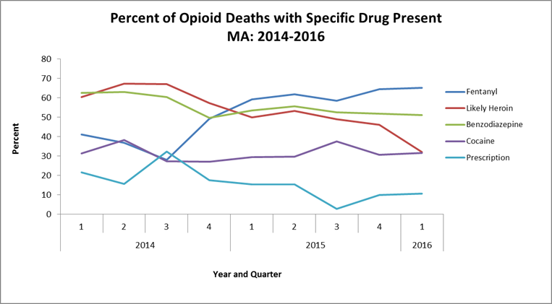

1. U.S. Department of Justice, Drug Enforcement Administration, DEA Investigative Reporting, January 2015.